**Installation of MetaMask**

1. Open the MetaMask Website: - <https://metamask.io/> and click on download

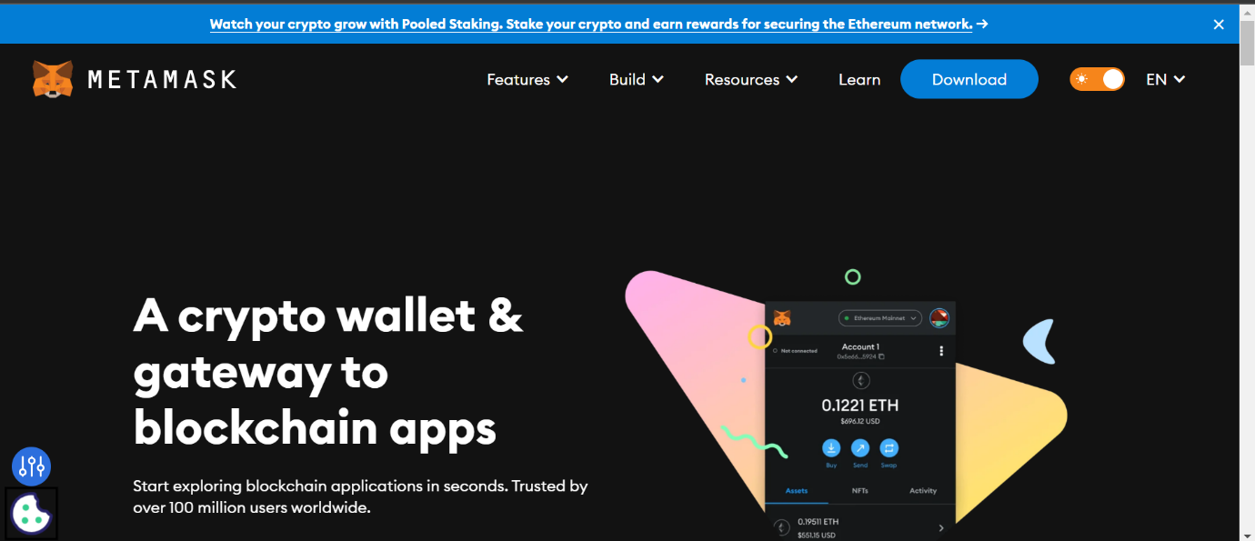

1. Click on Install MetaMask for chrome (or your working browser).

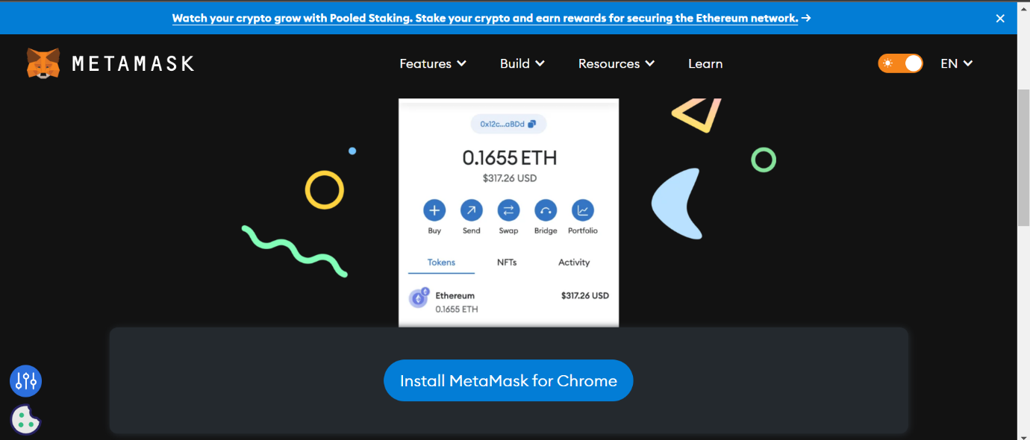

1. Add the MetaMask extension to the chrome browser.

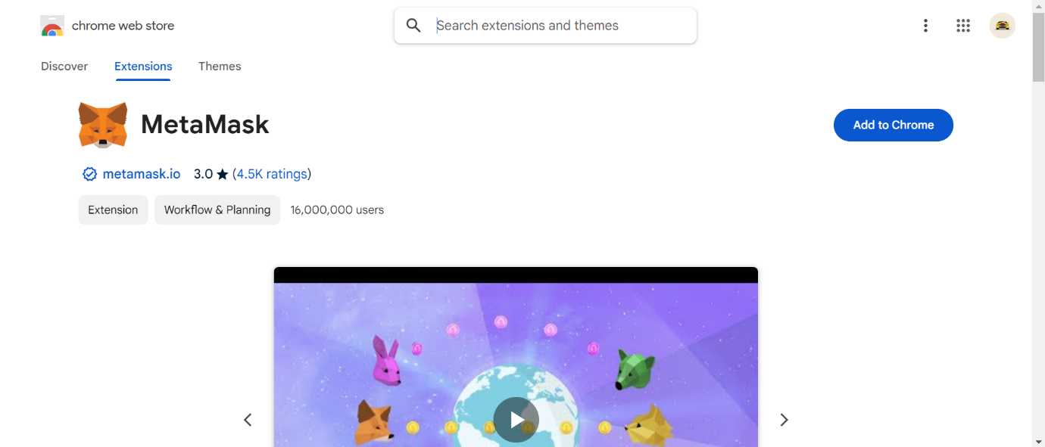

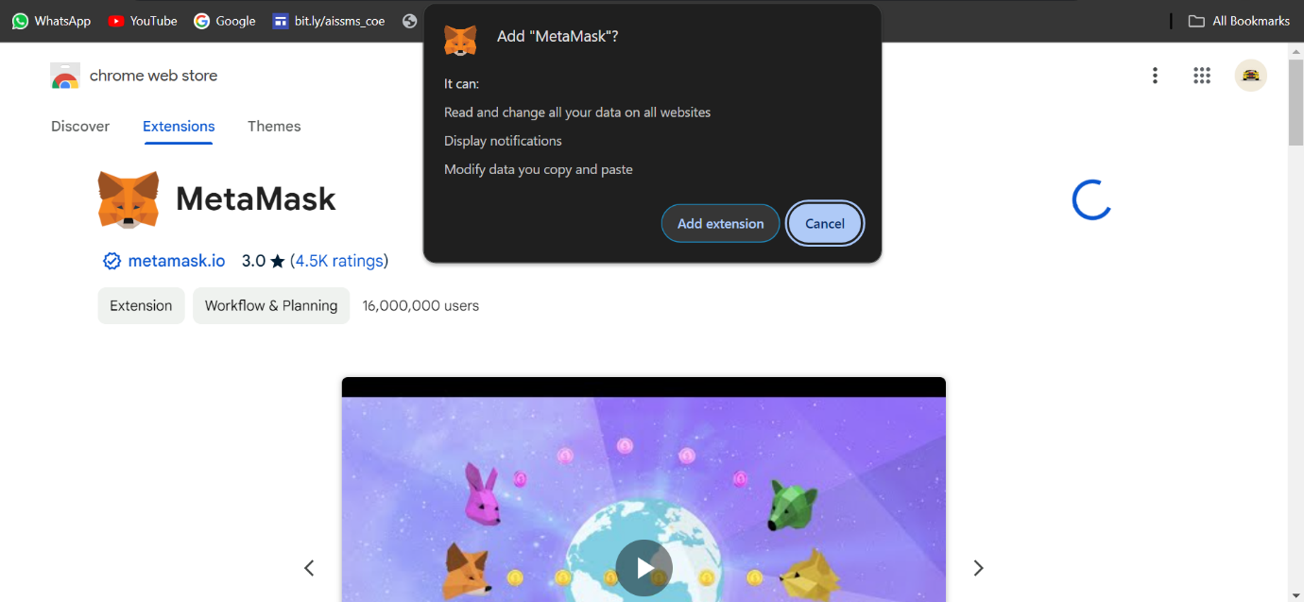

1. When the MetaMask app opens tick the Terms of use and create a new Wallet.

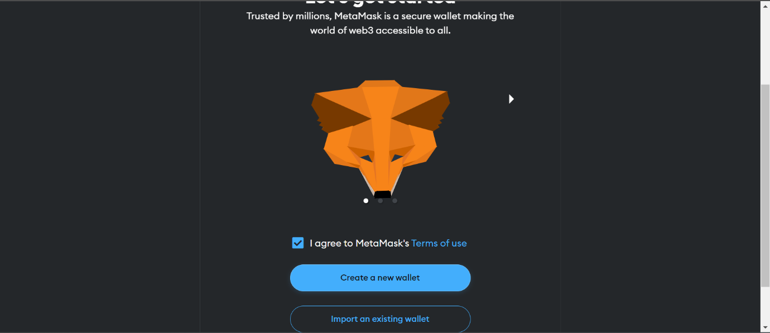

1. Click on I agree.

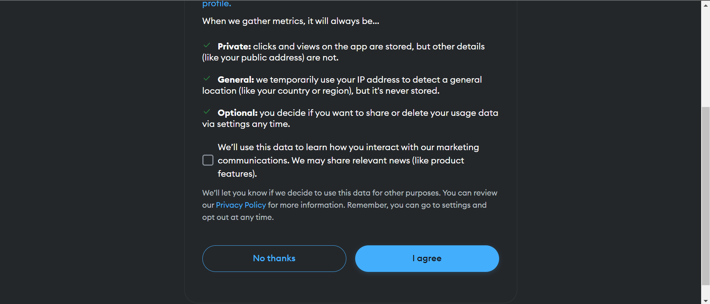

1. Create a password for the account.

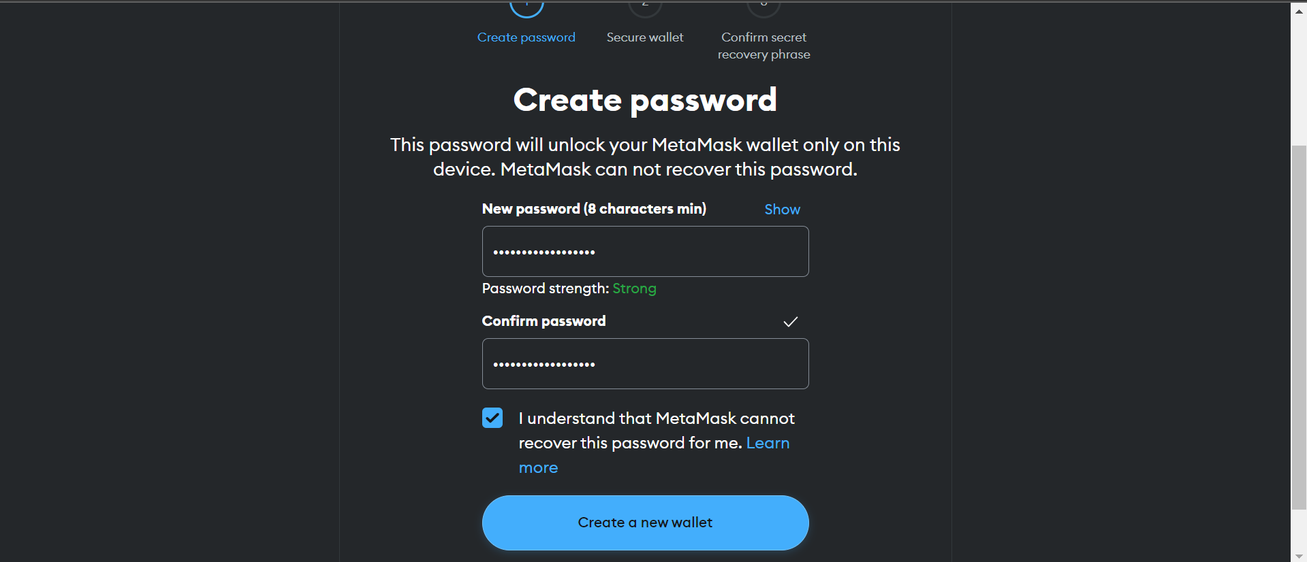

1. Click on Secure my wallet.

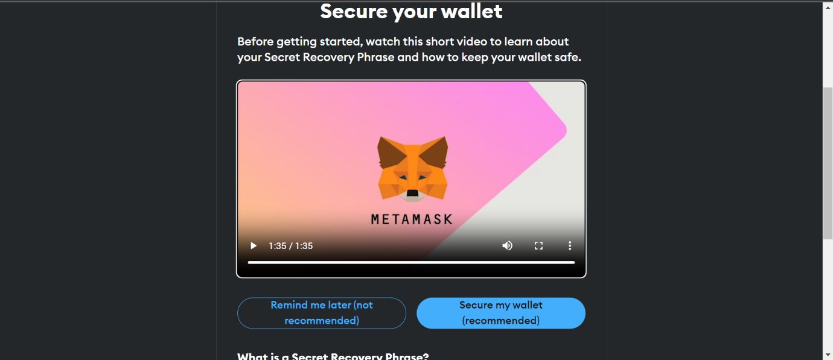

1. A 12 word Secret Recovery Phrase will be generated. Copy it in your notepad and do not share it to anyone.

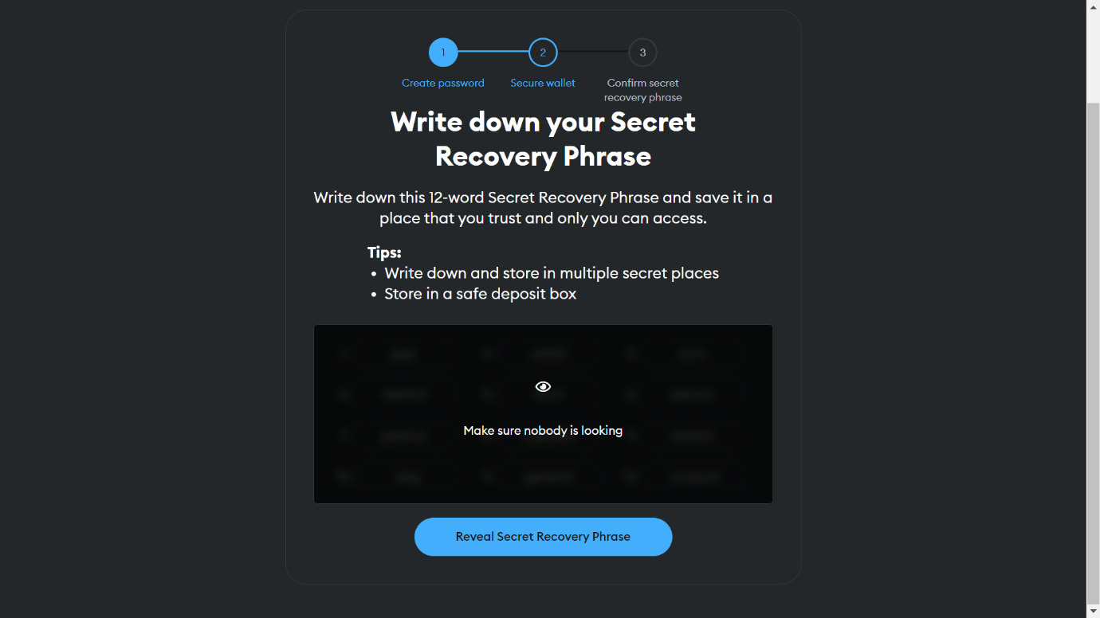

1. Fill the gaps from your Secret Recovery Phrase.

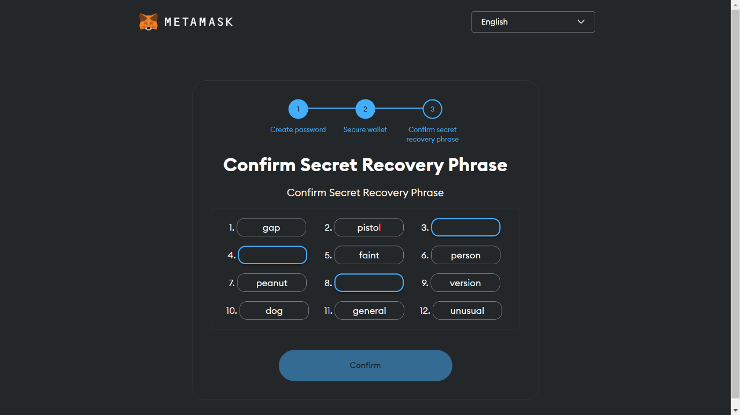

1. Your account and wallet is created successfully.

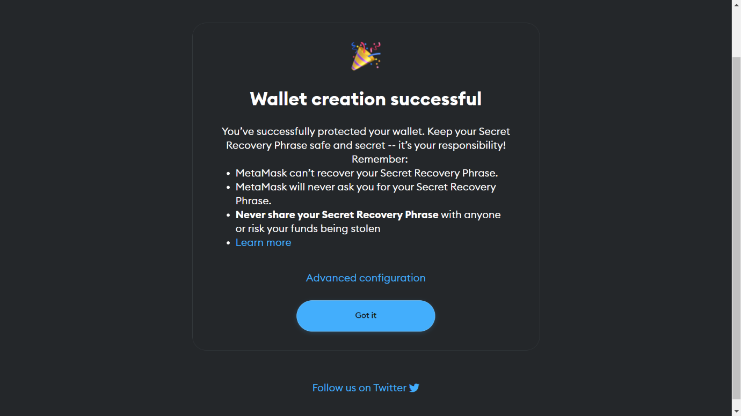

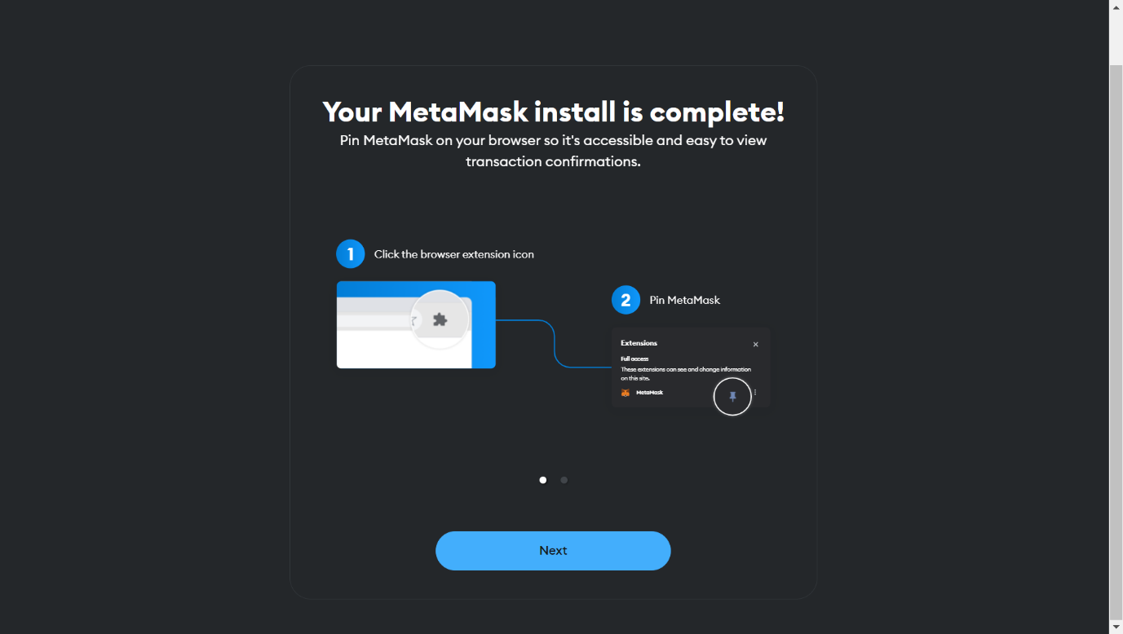

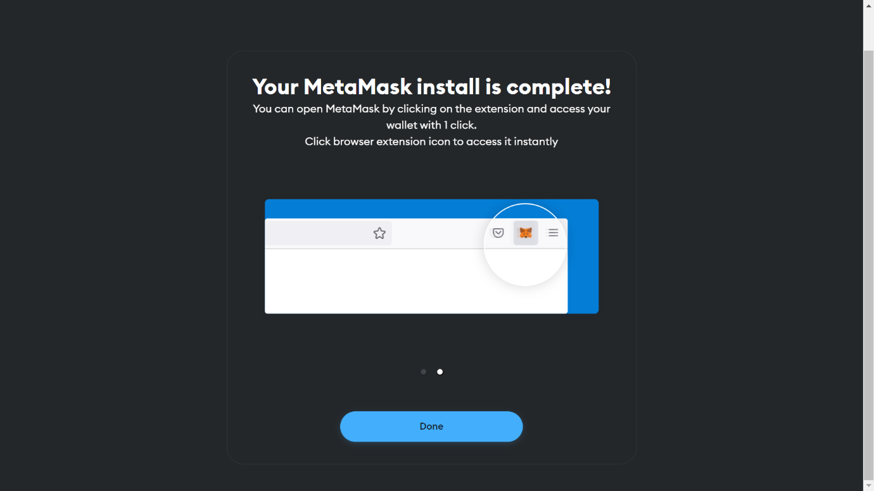

1. View your wallet in your dashboard.

